P1#yIS1

# ASSIGNMENT 1

|  |  |  |
| --- | --- | --- |
| Subject | : | Technology and Information System (SECP1513) |
| Session | : | 2023/2024 Semester 1 |
| Task | : | Visit to New Academia Learning Innovation (NALI 2023)  on 7th and 8th November 2023 |
| Title | : | Report on Visit to NALI 2023 |
| Duration | : | 1 Week (14 November 2023 until 20 November 2023  before 12.00 am) |
| Submission | : | This is a **GROUP WORK** and submit it **INDIVIDUALLY** |
|  |  | 1. Upload report (in .pdf format) via UTM E-learning 2. Upload report (in .pdf format) via GitHub (**A WEEK** after a submission through UTM E-learning) |

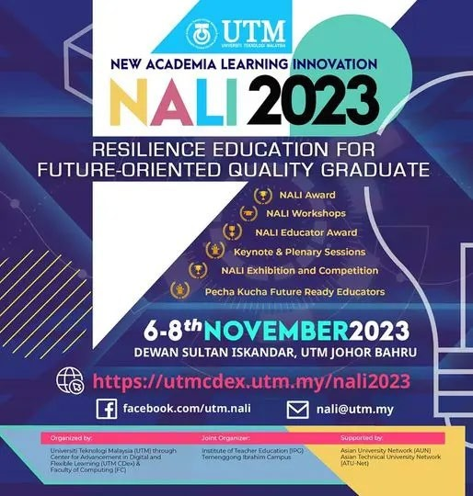

Poster on NALI 2023

Group 2: Ibnu Sina

Name: AMMAR QHAWIEM BIN MOHD ASRAK (A23CS0045)

IZZ HAEIL BIN HAMISHAMSUL (A23CS0088)

MUHAMMAD HAIKAL BIN JAPRI (A23CS0131)

ABDUL BARIK HABIBI BIN MOHD ISKANDA (A20EC8024)

**NALI introduction**

NALI is an annual knowledge sharing event organised by Universiti Teknologi Malaysia (UTM), through Center for Advancement in Digital and Flexible Learning (UTM CDex). NALI also stands for New Academia Learning Innovation, a framework to promote innovative teaching and learning practices in education. It comprises student-centred and blended learning philosophy, multiple learning modes and materials towards achieving entrepreneurial academia. The first edition of NALI was organised in 2018. Over the past two years, the organisers have put together a series of activities under NALI such as Keynote and Plenary sessions, K-sharing Workshops, Exhibition and Competition, Pecha Kucha NALI Educators.

Pecha Kucha presentation is a format that uses 20 slides or images, each shown for 20 seconds. This format was introduced and popularised by Astrid Klein and Mark Dytham of Klein-Dytham Architecture. They created Pecha Kucha in February 2003 when they founded Pecha Kucha. This format ensures that the speaker is brief, keeps the presentation moving and conveys the entire content. The basic idea of the Pecha Kucha presentation is “talk less, show more”. Pecha Kucha is a Japanese word meaning ‘chit-chat’. Today, Pecha Kucha is the fastest growing storytelling platform in the world, used by millions of people around the globe to share passions and impart knowledge. The visually compelling presentation should be simple and create authentic connections in less than 7 minutes.

There are four results in NALI such as Exhibition and Competition Results, this award is presented to innovators who have demonstrated excellent practice or project or product in teaching and learning innovation. For your information, this year we have 90 participants for the NALI Exhibition & Competition. After that, NALI Best of the Best Results, this award is presented to the Gold Medal recipient for the NALI EXHIBITION AND COMPETITION with the highest score. Furthermore, NALI Best Educator Award Results, this award honors individuals that displayed a passion for their subject matter, an understanding of pedagogy, and fostering a love for learning and instilling lifelong skills as a teacher. Last but not least, NALI Award Results, this award is given to innovators who demonstrate excellent practice/project/product related to New Academia Learning Innovation (NALI) which is makes a significant impact on teaching and learning which also include the integration of technology. The award is looking for innovators that revolutionize teaching and learning.

**Explanation of the Innovation from the poster: Izz Haeil bin Hamishamsul (A23CS0088)**

This poster explains about learning commercial law using Kahoot! for non-law background students. It is part of a new learning innovation initiative at the University of Technology Malaysia (UTM) in 2023. The poster highlights the benefits of using “Kahoot!” which is a Norwegian game-based student response system. This online game-based learning platform has potential to enhance classroom engagement, motivation, and overall learning experiences because it has an interesting feature that can attract students to have a better understanding on what they study.

Furthermore, “Kahoot!” quizzes and surveys can be used to assess students' understanding of commercial law concepts. This feedback can help students to identify areas where they need more help and to focus their learning accordingly. It also mentions that “Kahoot!” can be used to improve the quality of classroom learning as compared to traditional classrooms, and to reduce distractions during study session.

In addition, “Kahoot!” games and activities can help students to retain information for longer periods of time. This is because “Kahoot!” uses a variety of learning modalities, such as visual, auditory, and kinesthetic learning. It is a valuable resource for lecturers who are looking for ways to make their lessons more engaging and effective. In conclusion, “Kahoot!” is a versatile tool that can be used in a variety of ways to improve student learning.

**Interview session about the poster:**

<https://www.youtube.com/watch?v=CLa_HqDTJHM>

Reflections and Conclusion

**1. Do the activities give benefit to the student?**

Absolutely, the activities in NALI 2023 are designed to be engaging and informative, and they can help students to learn and retain information more effectively. Additionally, the activities can help students to develop critical thinking skills, problem-solving skills, and collaboration skills which are necessary skills needed for the students during the study session.

**2. How do these activities impact on the outcome of the course/subject?**

The activities in NALI 2023 are making a positive impact on the outcome of the course/subject. By participating in the activities, students can learn new concepts, practice applying their skills, and receive feedback from their peers and instructors. This will help students to improve their understanding of the course material and to achieve better grades. By having this objective achieved, students can implement the skills into their life for a better vision on everything they will anticipate.

**3. Do you learn something impactful from the activity?**

Definitely, I learned something beneficial from the NALI 2023 activity such as the benefits of using “Kahoot!” for teaching and learning new things. This shows that there are a lot of medium to learn new things or make an effective teaching style that will make students have a better understanding of what they major in. Furthermore, this innovative thought makes me want to further my study by having a deep understanding of how to invent an innovation that can be used for something more contrivance.

**4. Do the activities spark excitement/interest in the student?**

Undoubtedly, the activities in NALI 2023 are designed to be exciting and interesting for students. The activities are interactive, competitive, and creative which are more likely to get their hands on something new or something more challenging. Additionally, the activities are relevant to the students' interests, as they focus on Information and Communication Technologies (ICT), which is an important study for the computing students. Moreover, the students live in a modern global situation which makes this knowledge very necessary for their future to show how it implement in their working lives.

**5. Do you feel that the visiting NALI 2023 and the interview sessions help you learn the course material better? Provide justification.**

After visiting NALI 2023 and interviewing the representator, my perception of the course material is more likely to improve. By visiting NALI 2023, I would be able to learn about the latest trends and developments in learning and teaching. Additionally, I need to network with other professionals and students in the field. By interviewing the participant, I can learn from experts in the field of Information and Communication Technologies (ICT) which help me in advancing my study and to get their insights on the most important concepts and topics to learn. Moreover, I would be able to get their feedback on my own understanding of the course material. Overall, I believe that visiting NALI 2023 and having the interview sessions would be a valuable learning experience that can help me to learn the course material better.

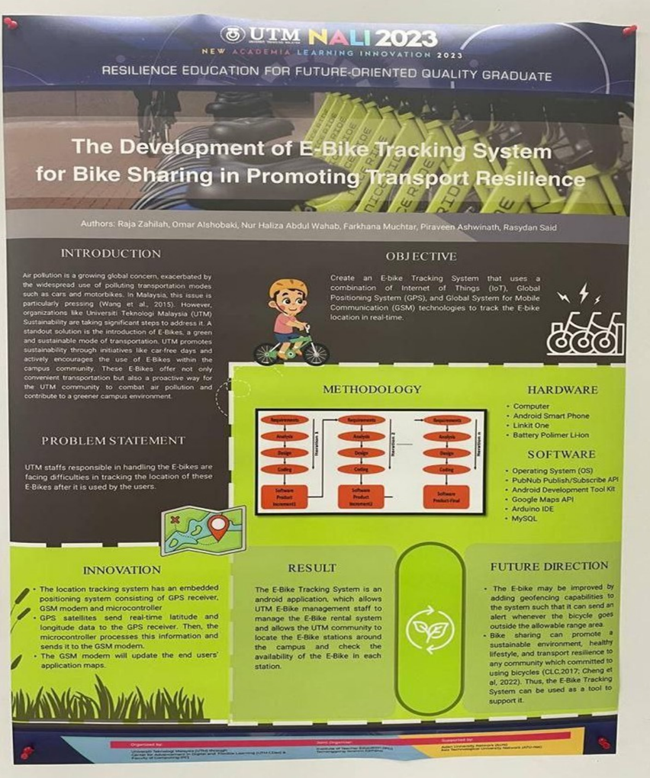

**E-BIKE TRACKING SYSTEM: MUHAMMAD HAIKAL BIN JAPRI (A23CS0131)**

The Malaysia Air Quality Index is a cause for concern as it poses a threat to various aspects of life in Malaysia, including the well-being of its population. In light of this, one viable solution is the adoption of e-bikes, which do not rely on petroleum like traditional vehicles. Recognizing the need to address air pollution and create a more sustainable world, UTM has introduced e-bikes as an alternative mode of transportation. These e-bikes not only offer convenience but also serve as a proactive measure for the UTM community to combat air pollution and contribute to a greener campus environment. However, a significant challenge lies in ensuring the security of these e-bikes and tracking their location after use.

To address this challenge, UTM has developed an e-bike tracking system, which is a straightforward approach to monitor the whereabouts of these vehicles. This tracking system combines three essential components: the Internet of Things (IoT), the Global Positioning System (GPS), and the Global System for Mobile Communication (GSM). By integrating these systems, the tracking system becomes more efficient and user-friendly. The hardware requirements for building this system include a computer, an Android smartphone, Linkit One, and a Li-ion Polymer battery. On the software side, the necessary components are the Operating System (OS), Android Development Toolkit, Google Maps API, Arduino IDE, and MySql.

The modernization of this system lies in its embedded positioning system, which consists of a GPS receiver, GSM modem, and microcontroller. GPS satellites provide real-time latitude and longitude data to the GPS receiver, which is then processed by the microcontroller. Subsequently, this information is transmitted to the GSM modem, which updates the end user's application maps. The e-bike tracking system takes the form of an Android application, enabling UTM's e-bike management staff to oversee the rental system and allowing the UTM community to locate e-bike stations across the campus.

Overall, the implementation of the e-bike tracking system at UTM serves as a practical solution to ensure the security and efficient management of these vehicles. By leveraging IoT, GPS, and GSM technologies, UTM can effectively track the location of e-bikes, contributing to a safer and more sustainable transportation system within the university campus.

**Interview session about the poster:**

<https://www.youtube.com/watch?v=CLa_HqDTJHM>

**REFLECTION AND CONCLUSION**

1. Of course, this activity benefits students since it provides them the courage to ask the participants in this activity a variety of questions and students are exposed by the new invention for them to use in future.

2. The course's output has an impact on industry visits and industry lectures, both of which are part of work-based learning and are part of NALI (New Academic Innovative Learning). They help us understand the role of ICT in various types of enterprises, such as ICT as a core business or ICT as a business enabler. Furthermore, students can discover the prerequisites and work standards for a career in ICT.

3. Yes, I discovered that ICT plays an important part in our developing country, and most students were unaware that Malaysia has a diverse range of competent companies. Then NALI became our hero for disseminating and disclosing information about the firms and technology they invented. Aside from that, communication skills must be a critical soft skill that everyone must possess. It will make something easier, such as the interview, appear clearer and more understandable.

4. This activity excites us because we can see the innovation for us and the next generation to use. For example, the e-bike tracking system was a fantastic invention for locating the bike and preventing it from being stolen. Who isn't enthralled by such a grandiose concept? Aside from that, Discord extensions are specifically designed to help Discord group members get to know one another.

5. Yes, visiting NALI was a memorable experience for me and my team, and it is even more special because it has only been hosted by UTM since 2018. The interview session was fantastic, and it was a new experience for me because I had never interviewed anyone before. So, I believe I accepted the challenge to step outside of my comfort zone, and these sessions will help me improve my communication and social skills.

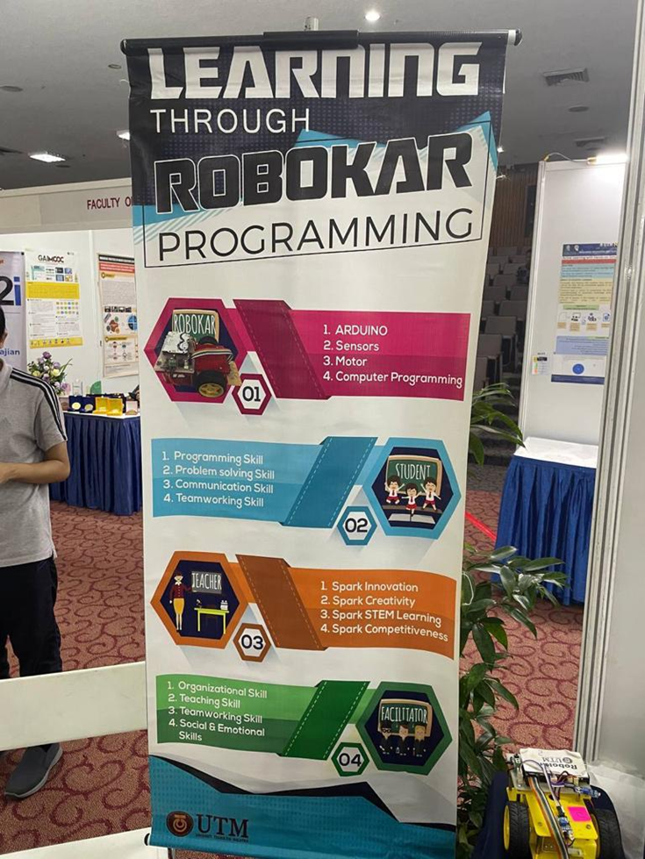

**Explanation: ABDUL BARIK HABIBI BIN MOHD ISKANDA (A20EC8024)**

Robokar programming, which incorporates Arduino, sensors, motors, and computer interfaces, provides a dynamic platform for students to explore the world of Information and Communication Technology (ICT). This multidisciplinary method integrates hardware and software components, allowing students to not only comprehend the complexities of programming but also obtain practical knowledge of robotics and automation. The combination of these technologies results in an engaging learning experience that promotes a greater understanding of STEM ideas.

Students become active participants in their educational experience when they participate in Robokar programming. They learn programming skills by creating code to operate the Robokar while also improving their communication and collaboration abilities. Students cooperate on Robokar projects to engage in debates, communicate ideas, and problem-solve jointly. This collaborative atmosphere not only improves their technical abilities but also fosters important soft skills that are becoming increasingly important in today's networked and collaborative workplaces.

Teachers act as ICT innovation catalysts by creating and conducting Robokar projects that encourage creativity and critical thinking. Teachers can encourage students to explore diverse programming methodologies and problem-solving approaches by implementing these projects. Robokar programming, by integrating theoretical principles with real-world applications, offers a canvas for instructors to build an enthusiasm for STEM study. Teacher-organized competitions increase student motivation by instilling a sense of accomplishment and competitiveness.

Facilitators are critical in arranging successful Robokar programming projects. Their organizational abilities guarantee that the learning environment encourages experimentation and discovery. Facilitators work with instructors to arrange projects, give advice, and ensure that students have access to the materials they require. Facilitators handle the social and emotional components of learning, establishing a pleasant environment in which students feel encouraged to take chances and learn from their experiences.

The use of Robokar programming into educational environments goes beyond traditional limitations, providing a comprehensive learning experience. Students not only learn programming and robotics, but they also learn important communication, collaboration, and problem-solving skills. Through their unique techniques, teachers and facilitators foster a love for STEM learning and give students with opportunity to apply theoretical knowledge in practical scenarios. As the educational environment evolves, Robokar programming continues to shine as a light of innovation, molding the next generation's knowledge of ICT and preparing them for the challenges of the digital era.

**Interview session about the poster:**

<https://www.youtube.com/watch?v=CLa_HqDTJHM>

**Reflection**

Participating in Robokar programming activities has shown to be a transforming experience for both kids and instructors. When considering the advantages of these activities, it is clear that students have garnered significant benefits. Because Robokar programming is hands-on, they have gained practical programming skills while also developing excellent communication and collaboration. Seeing the actual results of their efforts in effectively managing and manipulating the Robokar has fostered in pupils a feeling of achievement and confidence.

These activities have a significant influence on the overall result of the course or subject. Students have developed a comprehensive grasp of STEM principles, comprehending the interconnectivity of multiple disciplines, in addition to technical expertise. The learning process has been enhanced by this integrated method, which gives theoretical concepts a real-world application. The educator-selected Robokar programming projects have grown to be essential in bridging the knowledge gap between classroom theory and practical implementations.

For me as a teacher, leading pupils through Robokar programming exercises has had a significant influence. These projects' obstacles have stimulated creativity and problem-solving abilities, offering insightful information on successful teaching techniques. A reevaluation of teaching approaches has been inspired by the process of assisting student learning in this dynamic setting, with a focus on the significance of experiential learning and collaborative discovery.

The learning experience has been greatly enhanced by the visit to NALI 2023 and the ensuing interview sessions. Viewpoints have been widened by exposure to cutting-edge concepts, developing technology, and the chance to communicate with subject matter specialists. The knowledge acquired from these encounters has strengthened the course contents and added practical context, which has made the material more relatable and tangible. Specifically, the interviews have provided an inside look at industry practices and trends, giving instructors and students useful information for future skill applications.

In conclusion, the inclusion of Robokar programming exercises in the curriculum has been a huge success. The advantages for learners, the revolutionary influence on learning objectives, the individual growth experiences of instructors, and the general enthusiasm among the attendees bear witness to the efficacy of this inventive methodology. Robokar programming is like a lighthouse guiding us through the ever-changing terrain of education, showing the way to a more dynamic, captivating, and memorable educational experience.

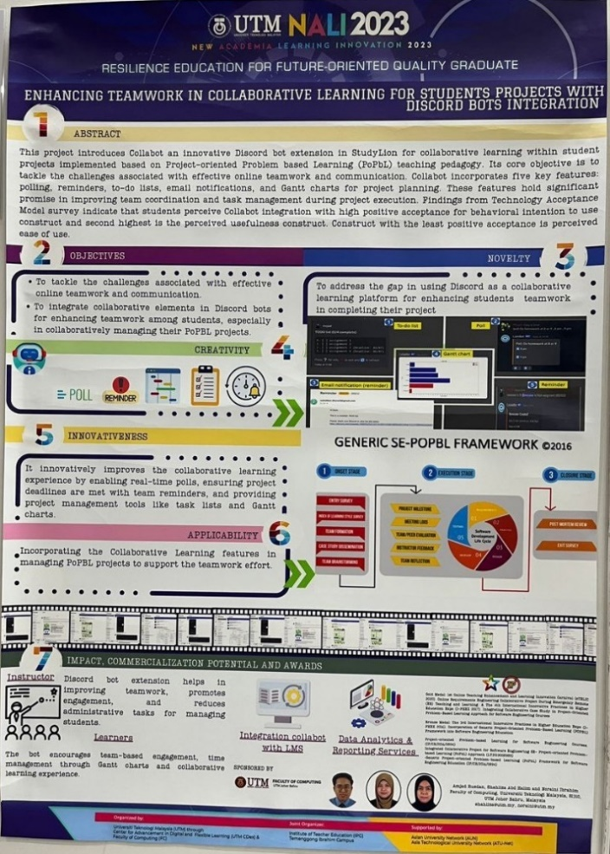

**Explanation: AMMAR QHAWIEM BIN MOHD ASRAK (A23CS0045)**

Innovation of this poster is to maximize the using of an app called Discord which is familiar among the student. Its core objective is to tackle the challenges associated with effective online teamwork and communication. This innovation is introducing the features which are the system polling, reminders,to-do lists, email notifications and Gant charts for project planning. The student can take this advantage to improve their projects learning. Its more effective and easier for student to let Collabot do their job.

Others than that, this poster mention that the gap in using Discord as a collaborative learning platform for enhancing students teamwork in completing their project. For instance, the features like polling or Gant chart really help student to collect data among student and to show that data to look more effective for their project.

Impact on this innovation on this society can be seen as good impact. Instructor Discord bot extension helps in improving teamwork, promotes engagement, and reduces administrative tasks for managing student. For the learners, the bot encourages team-based engagement, time management through Gant charts and collaborative learning experience.

**Interview session about the poster:**

<https://www.youtube.com/watch?v=CLa_HqDTJHM>

**CONCLUSION:**

1. NALI is really helped the student to open their mind in many ways, like what Dr. Shahliza said that student can take this opportunity to know what innovation is going to involved. Its really motivate me as a student to follow their job to make makes a new thing not just specific on education but more.

2. Basically NALI, it has some element or activity that TIS is really be used likes innovation in robotic or Virtual Reality (VR) headset. From student perspective view, NALI is figure that motivate as a student to create an innovation. So, TIS is the one of the courses related to the innovation in this NALI 2023 competition.

3. I learned that it has many ways that can be use by rely on technology to help student or others in their life. Its not depend what other have invented or system that be existed, maybe we can create a new system that help in our daily life.

4. Yes, the activity really sparked excitement or interest among the student. For examples the VR program is really seem like a very interesting. The work behind the scene likes how to create it, show its not easy as we can see but it quite looks “fun” to learn about it.

5. Yes, as I mentioned before TIS is very related to what activity in NALI have been involved. For examples one of my talked to participant that involve in NALI, he says that we must have soft skill on develop on prototype like a robot or drone. So, managing on hardware like small chip is very related on what on TIS course material.